Assignment Description:
This individual assignment focuses on building a computer vision system to automate quality control for push pin manufacturing. Using object detection, the model must classify pins into defined defect categories and determine whether a box meets acceptance criteria based on visual inspection.
Assignment Objectives:
The objective of this assignment is to develop a quality control visual inspection system that can automatically determine if a box of push pins is acceptable or should be rejected. The system will use object detection to identify good and bad pins and classify them into different categories. The goal is to train a model to inspect boxes and make decisions based on visual data.
Problem Statement:
You are tasked with building an AI-based quality control system for a company that manufactures push pins. Each box is divided into 15 bins, with exactly one good pin per bin. You need to build a visual inspection system that detects and classifies pins into different categories that are listed in Classes section. Based on the classification, the box will either be accepted or rejected.
Assignment Guidelines:
- Please follow this path to submit the assignment on LMS (racelms.reva.edu.in). Sign in to LMS and go to dashboard (Topmost option on Left most side column) > Go to the channel –> Go to the post “Assignment & Assessments” > On the right-hand side of the screen you will see – “AI11 | SEM 02 | Module 06 | Computer Vision and GenAI | Bismillah Kani | Assignment 1…” > Click on “Start” > Upload your assignment.
- Since it is an individual assignment, the submission must be individual.

Deliverables:
- Submit your annotated dataset in a proper format.
- Submit your Jupyter notebook or scripts with appropriate markdown and comments.
- Submit your trained model, along with evaluation metrics (graphs, charts, or confusion matrices).
- Include a final report summarizing the project, key challenges, model performance, and final decisions.
- Zip all the above along with script file and submit it.

Submission Details:
- Deadline: 26th June 2025
- Submit via the assignment link created in the LMS as a zipped folder with the report and presentation deck.
Dataset:
The dataset contains a total of 310 images, split into:
- 138 images labelled as 'good'.
- 172 images labelled as 'bad'.
Each image is prefixed with either 'good' or 'bad' for easy differentiation.
Dataset is available in LMS - https://bit.ly/4e7KT3R

Classes:
No | Class | Description | Example (not exhaustive)
1 | 1_pin | A single good pin in a bin | 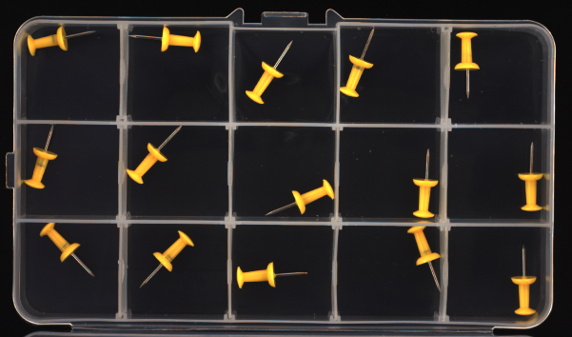
2 | 2_pin | Two pins present in a single bin | 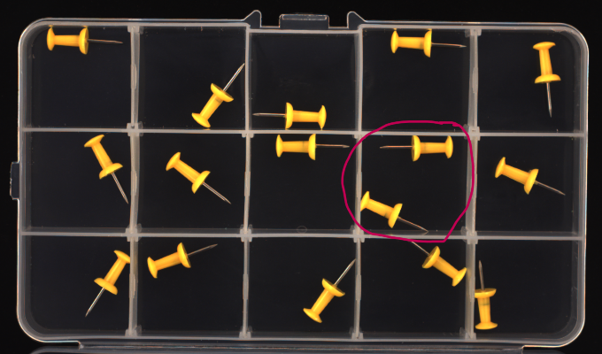
3 | 3_pin | Three pins present in a single bin | 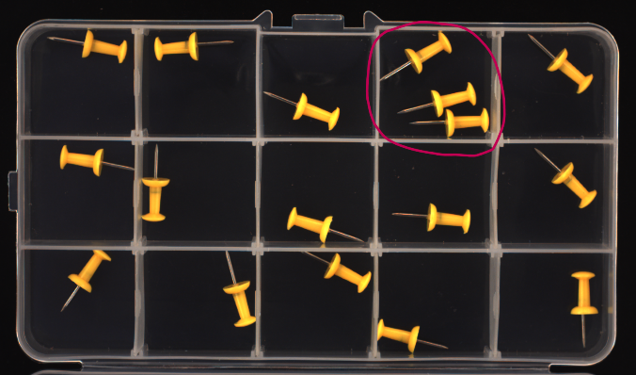
4 | missing_pin | No pin present in the bin | 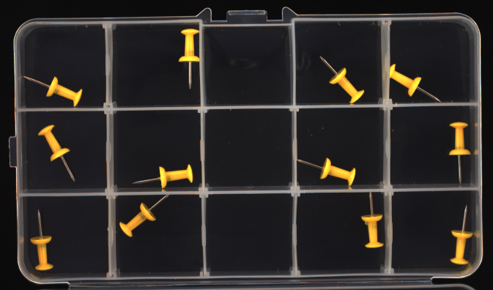
5 | front_bend | A pin where the head or tip is bent | 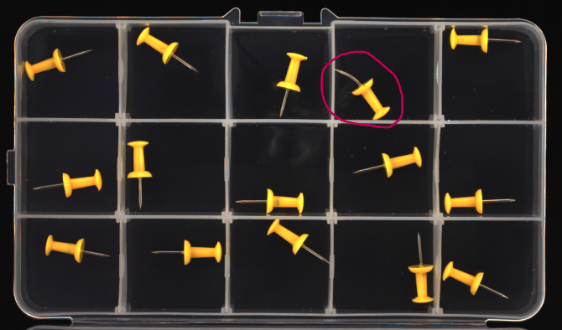
6 | broken | The pin is broken or incomplete. | 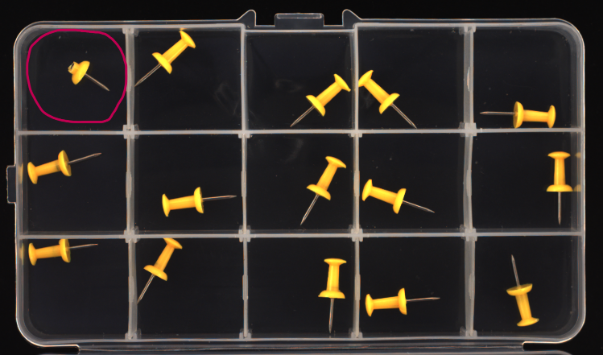
7 | wrong_color | A pin with a color different from the expected yellow. | 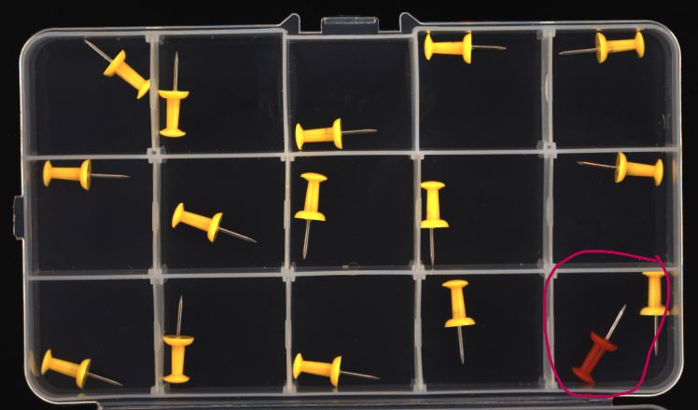
8 | contamination | Foreign objects in the bin. | 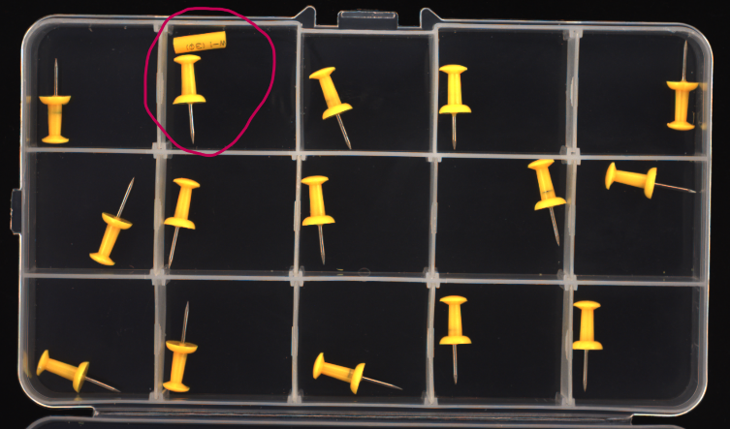
9 | missing_separator | A separator between bins is missing. | 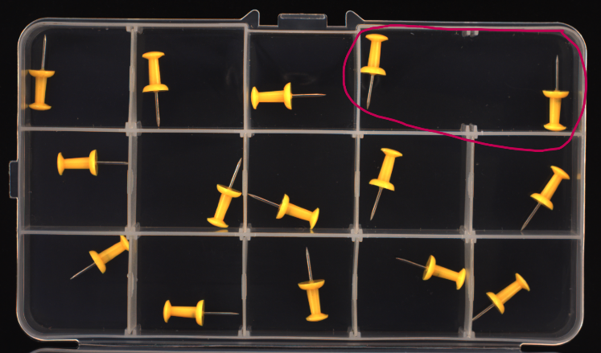

Steps to follow:
- Dataset Preparation (4 marks):
- Use labelling tools (Ex. CVAT) to annotate the different types of objects as explained in Classes in each bin.
- Export the dataset in a suitable format. Ex. YOLO
- Dataset Split: Split the dataset into a 90-10 split: 90% for training and 10% for testing. Ensure the test split has at-least 7 bad images.

- Model Training (8 marks):
- Train an object detection model leveraging transfer learning by fine-tuning a pre-trained model. You can use any object detection framework such as Ultralytics YOLO (recommended).
- Experiment with different architectures (YOLOv5, YOLOv8, etc.), data augmentation and hyperparameters.
- Evaluate the models using mean average precision (mAP) or other relevant metrics.
- Compare and select the best model from the experiments.

- Model Evaluation (5 marks):
- Performance Reporting: Evaluate the model on the unseen test set and report key performance metrics:
- Precision-Recall Curves: Provide visual analysis of precision and recall across different thresholds.
- Confusion Matrix: Display the classification performance of the model across all classes.
- Report mean average precision (mAP) and other relevant evaluation metrics to assess the model's performance.

- Box Accept/Reject Method (3 marks):
- Implement a method to determine if the box is accepted or rejected based on the following criteria:
- Accept the box if it contains exactly 15 good pins (1_pin) and no bad pins.
- Reject the box if it contains any bad pins (front_bend, broken, wrong_color, contamination, missing pins, or missing separators).
- Additionally, reject the box if any bin has more than one pin or if a separator is missing.

Outcome:
- Successfully label a dataset for object detection.
- Train and evaluate an object detection model that can classify and detect pins in a box.
- Build a computer vision system that counts pins by class and makes acceptance/rejection decisions for quality control.

Plagiarism Policy:
- Ensure all submissions are original.
- Cite all sources used for research.

